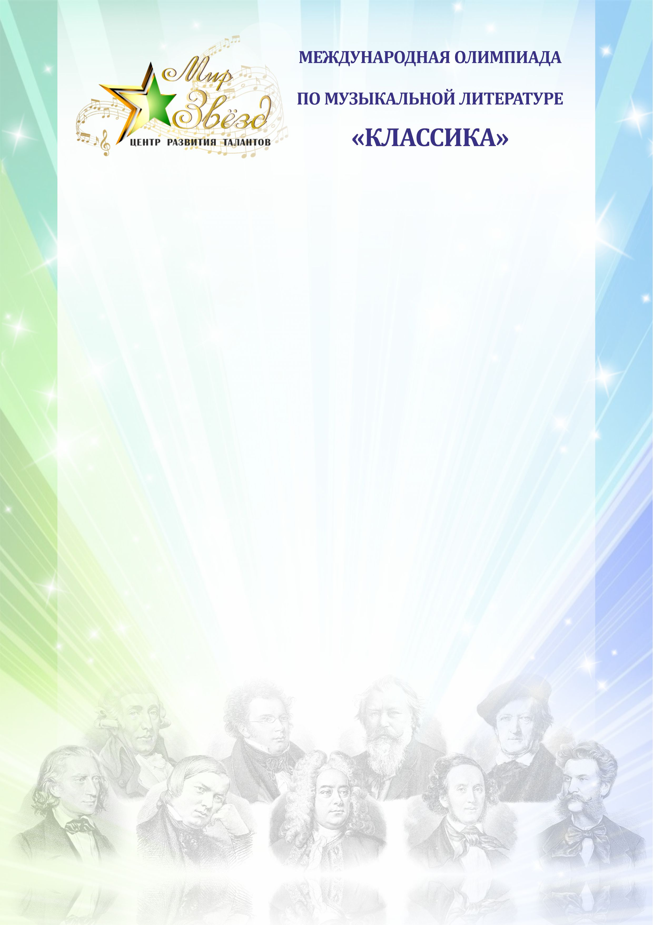

Международная олимпиада по музыкальной литературе «Классика»

ФИО участника
ФИО преподавателя
Учебное заведение

Задания 3 год обучения
- Какой период времени охватывает древнерусское искусство?
____________________________________________________________________________________________________________________________________________________________________________________________________________________________________________________________________________________________________________________________________________________________________________________________________________
- Что послужило толчком для развития русской национальной композиторской школы?
_______________________________________________________________________________________________________________________________________________________________________________________________________________________________________________________________________________________________________________________________________________________________________________________________________________________________________________________________________________________________________________________________________________________________________________________________________________________________________________________________________________________________________________________________________________________________________________________________________________________________________________________________________________________________________________________________________________________________________
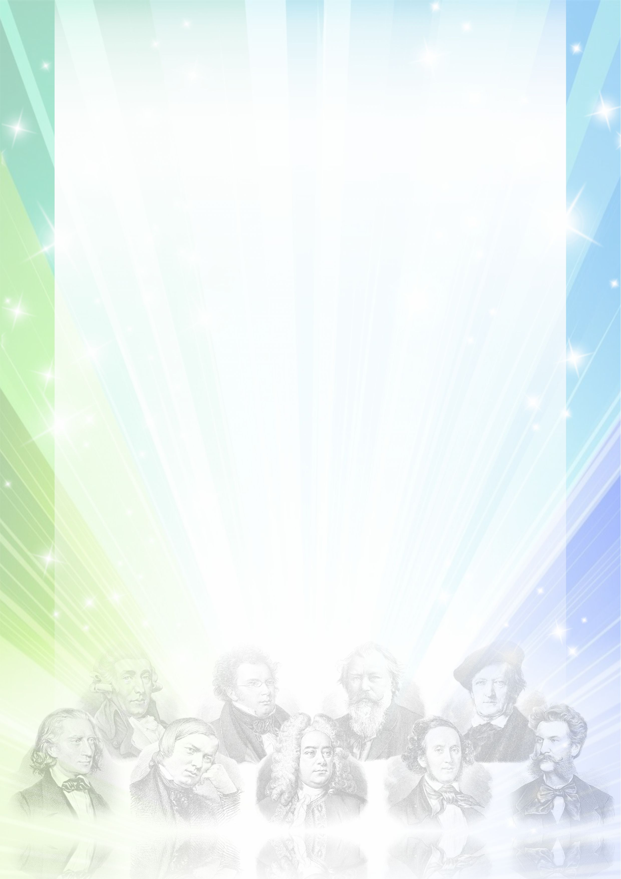
- Назови особенности русской комической оперы?
________________________________________________________________________________________________________________________________________________________________________________________________________________________________________________________________________________________________________________________________________________________________________________________________________________________________________________________________________________________________________________________________________________
- Какое подлинное событие легло в основу сюжета оперы «Иван Сусанин» М.И. Глинки?
______________________________________________________________________________________________________________________________________________________________________________________________________________________________________________________________________________________________________________________________________________________________________________________________________________________________________________________________________________________________________________________________________________________________________________________________________________________________________________________________________________________________________________________________________________________________________________________________________________________________________________________________________________________________________________________________________________________________________________________________________________________________________________________________________________________________________________________________________________________________________________________________________________________________________________________________________________________________________
- Назови известные тебе симфонические произведения М.И. Глинки и их важнейшую особенность?
________________________________________________________________________________________________________________________________________________________________________________________________________________________________________________________________________________________________________________________________________________________________________________________________________________________________________________________________________________________________________________________________________________________________________________________________________________________________________________________________________________________________________________________________________________________________________________________________________________________________________________________________________________________________________________________________________________________________________________________________________________________________________________________________________________________________________________________________________________________________________________________________________________________________________________________________________________________________________________________________________________________________________________________________________________________________________________________________________________________________________________________________________________________________________________________________________________________________________________________________________________________________________________________________________________________________________________________________________________________________________________________________________________________________________________________
- Расскажи о творчестве композитора А.С. Даргомыжского, в каких жанрах он писал, особенности, назови известные тебе произведения этого композитора?
______________________________________________________________________________________________________________________________________________________________________________________________________________________________________________________________________________________________________________________________________________________________________________________________________________________________________________________________________________________________________________________________________________________________________________________________________________________________________________________________________________________________________________________________________________________________________________________________________________________________________________________________________________________________________________________________________________________________________________________________________________________________________________________________________________________________________________________________________________________________________________________________________________________________________________________________________________________________________________________________________________________________________________________________________________________________________________________________________________________________________________________________________________________________________________________________________________________________________________________________________________________________________________________________________________________________________________________________________________________________________________________________________________________________________________________________________________________________________________________________________________________________________________________________________________________________________________________________
- Объясни, что такое «Могучая кучка», когда она сформировалась, какие композиторы в нее входили?
____________________________________________________________________________________________________________________________________________________________________________________________________________________________________________________________________________________________________________________________________________________________________________________________________________________________________________________________________________________________________________________________________________________________________________________________________________________________________________________________________________________________________________________________________________________________________________________________________________________________________________________________________________________________________________________________________________________________________________________________________________________________________________________________________________________________________________________________________________________________________________________________________________________________________________________________________________________________________________________________________________________________________________________________________________________________________________________________________________________________________________________________________________________________________________________________________________________________________________________________________________________________________________________________________________________________________________________
- Назови основные этапы жизни П.И. Чайковского?
________________________________________________________________________________________________________________________________________________________________________________________________________________________________________________________________________________________________________________________________________________________________________________________________________________________________________________________________________________________________________________________________________________________________________________________________________________________________________________________________________________________________________________________________________________________________________________________________________________________________________________________________________________________________________________________________________________________________________________________________________________________________________________________________________________________________________________________________________________________________________________________________________________________________________________________________________________________________________________________________________________________________________________________________________________________________________________________________________________________________________________________________________________________________________________________________________________________________________________________________________________________________________________________________________________________________________________________________________________________________________________________________________________________________________________________________________________________________________________________________________________________________________________________________________________________________________________________________________________________________________________________________________________________________________________________________________________________________________________________________________________________________________________________________________________________________________________________________________________________________________________________________________________________________________________________________________________________________________________________________________________________________________________________________________________
- Какую роль играет программность в произведениях П.И. Чайковского?
______________________________________________________________________________________________________________________________________________________________________________________________________________________________________________________________________________________________________________________________________________________________________________________________________________________________________________________________________________________________________________________________________________________________________________________________________________________________________________________________________________________________________________________________________________________________________________________________________________________________________________________________________________________________________________________________________________________________________________________________________________________________________________________________________________________________________________________________________________________________________________________________________________________________________________________________________________________________________

- Викторина наоборот! Представь, что ты учитель и тебе нужно подготовить викторину по русским композиторам классикам. Какие, бы ты включил в свою викторину произведения? (Напиши 10-15 примеров)
_____________________________________________________________________________________________________________________________________________________________________________________________________________________________________________________________________________________________________________________________________________________________________________________________________________________________________________________________________________________________________________________________________________________________________________________________________________________________________________________________________________________________________________________________________________________________________________________________________________________________________________________________________________________________________________________________________________________________________________________________________________________________________________________________________________________________________________________________________________________________________________________________________________________________________________________________________________________________________ Желаем удачи!

