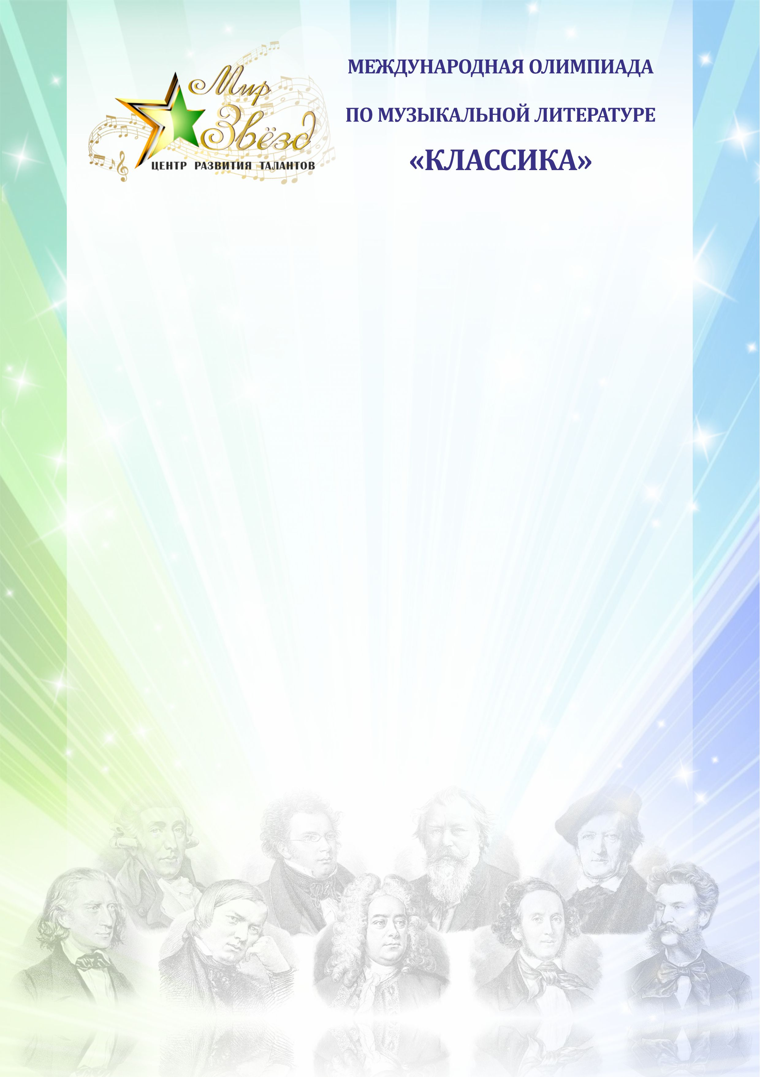

Международная олимпиада по музыкальной литературе «Классика»

ФИО участника
ФИО преподавателя
Учебное заведение

Задания 4 год обучения
- Какое место в мировой культуре занимала русская музыка на рубеже XIX и XX вв.?
__________________________________________________________________________________________________________________________________________________________________________________________________________________________________________________________________________________________________________________________________________________________________________________________________________________________________________________________________________________________________________________________________________________________________________________________________________________________________________________________________________________________________________________________________________________________________________________________________________________________________________________________________________________________
- Назови имена меценатов, внесших большой вклад в развитие русской музыки XX в.?
_______________________________________________________________________________________________________________________________________________________________________________________________________________________________________________________________________________________________________________________________________________________________________________________________________________________________________________________________________________________________________________________________________________________________________________________________________________________________________________________________________________________________________________________________________________________________________________________________________________________________________________________________________________________________________________________________________________________________________

- Назови известные тебе произведения А.К. Лядова?
________________________________________________________________________________________________________________________________________________________________________________________________________________________________________________________________________________________________________________________________________________________________________________________________________________________________________________________________________________________________________________________________________________
- Расскажи о творчестве В. С. Калинникова?
______________________________________________________________________________________________________________________________________________________________________________________________________________________________________________________________________________________________________________________________________________________________________________________________________________________________________________________________________________________________________________________________________________________________________________________________________________________________________________________________________________________________________________________________________________________________________________________________________________________________________________________________________________________________________________________________________________________________________________________________________________________________________________________________________________________________________________________________________________________________________________________________________________________________________________________________________________________________________
- Назови основные этапы жизни С.В. Рахманинова?
________________________________________________________________________________________________________________________________________________________________________________________________________________________________________________________________________________________________________________________________________________________________________________________________________________________________________________________________________________________________________________________________________________________________________________________________________________________________________________________________________________________________________________________________________________________________________________________________________________________________________________________________________________________________________________________________________________________________________________________________________________________________________________________________________________________________________________________________________________________________________________________________________________________________________________________________________________________________________________________________________________________________________________________________________________________________________________________________________________________________________________________________________________________________________________________________________________________________________________________________________________________________________________________________________________________________________________________________________________________________________________________________________________________________________________________
- Расскажи о творчестве композитора С.В. Рахманинова, в каких жанрах он писал, особенности, назови известные тебе произведения этого композитора?
______________________________________________________________________________________________________________________________________________________________________________________________________________________________________________________________________________________________________________________________________________________________________________________________________________________________________________________________________________________________________________________________________________________________________________________________________________________________________________________________________________________________________________________________________________________________________________________________________________________________________________________________________________________________________________________________________________________________________________________________________________________________________________________________________________________________________________________________________________________________________________________________________________________________________________________________________________________________________________________________________________________________________________________________________________________________________________________________________________________________________________________________________________________________________________________________________________________________________________________________________________________________________________________________________________________________________________________________________________________________________________________________________________________________________________________________________________________________________________________________________________________________________________________________________________________________________________________________
- Расскажи о творчестве композитора А.Н. Скрябина, в каких жанрах он писал, особенности, назови известные тебе произведения этого композитора?
____________________________________________________________________________________________________________________________________________________________________________________________________________________________________________________________________________________________________________________________________________________________________________________________________________________________________________________________________________________________________________________________________________________________________________________________________________________________________________________________________________________________________________________________________________________________________________________________________________________________________________________________________________________________________________________________________________________________________________________________________________________________________________________________________________________________________________________________________________________________________________________________________________________________________________________________________________________________________________________________________________________________________________________________________________________________________________________________________________________________________________________________________________________________________________________________________________________________________________________________________________________________________________________________________________________________________________________
- Расскажи о творчестве композитора С.С. Прокофьева, в каких жанрах он писал, особенности, назови известные тебе произведения этого композитора?
________________________________________________________________________________________________________________________________________________________________________________________________________________________________________________________________________________________________________________________________________________________________________________________________________________________________________________________________________________________________________________________________________________________________________________________________________________________________________________________________________________________________________________________________________________________________________________________________________________________________________________________________________________________________________________________________________________________________________________________________________________________________________________________________________________________________________________________________________________________________________________________________________________________________________________________________________________________________________________________________________________________________________________________________________________________________________________________________________________________________________________________________________________________________________________________________________________________________________________________________________________________________________________________________________________________________________________________________________________________________________________________________________________________________________________________________________________________________________________________________________________________________________________________________________________________________________________________________________________________________________________________________________________________________________________________________________________________________________________________________________________________________________________________________________________________________________________________________________________________________________________________________________________________________________________________________________________________________________________________________________________________________________________________________________________
- Назови известные тебе произведения Д.Д. Шостаковича?
______________________________________________________________________________________________________________________________________________________________________________________________________________________________________________________________________________________________________________________________________________________________________________________________________________________________________________________________________________________________________________________________________________________________________________________________________________________________________________________________________________________________________________________________________________________________________________________________________________________________________________________________________________________________________________________________________________________________________________________________________________________________________________________________________________________________________________________________________________________________________________________________________________________________________________________________________________________________________

- Викторина наоборот! Представь, что ты учитель и тебе нужно подготовить викторину по русским композиторам XX века. Какие, бы ты включил в свою викторину произведения? (Напиши 10-15 примеров)
_____________________________________________________________________________________________________________________________________________________________________________________________________________________________________________________________________________________________________________________________________________________________________________________________________________________________________________________________________________________________________________________________________________________________________________________________________________________________________________________________________________________________________________________________________________________________________________________________________________________________________________________________________________________________________________________________________________________________________________________________________________________________________________________________________________________________________________________________________________________________________________________________________________________________________________________________________________________________________ Желаем удачи!

