2023 Yamaha GP1800R SVHO. Price in Kaliningrad is 1350000 ₽

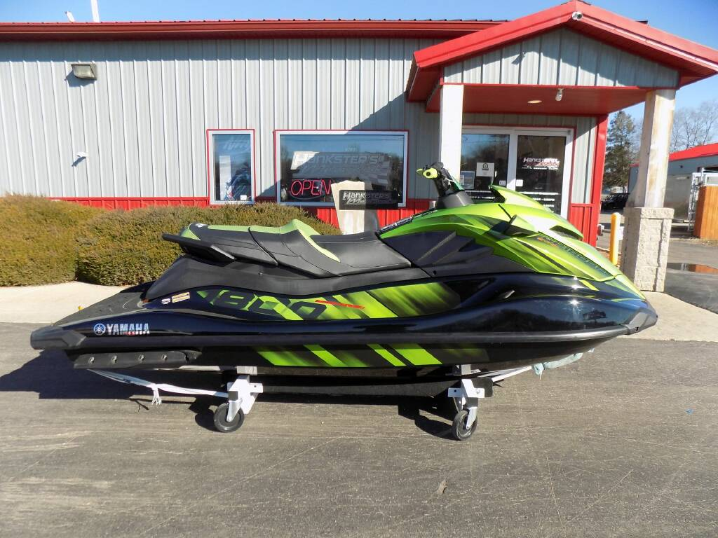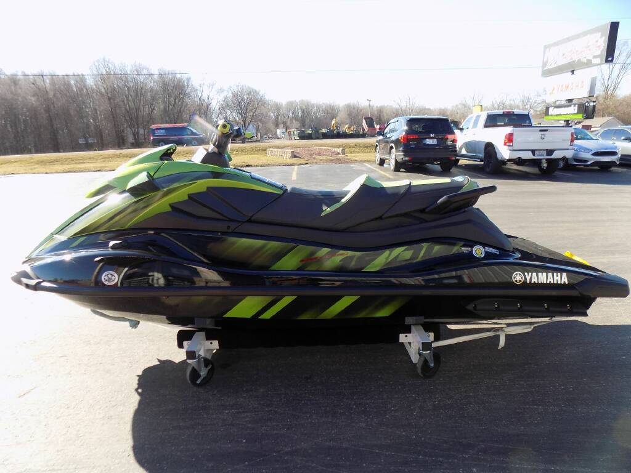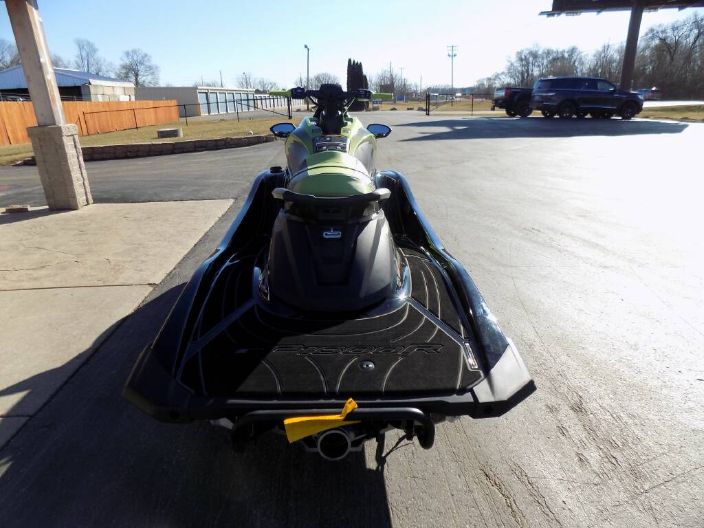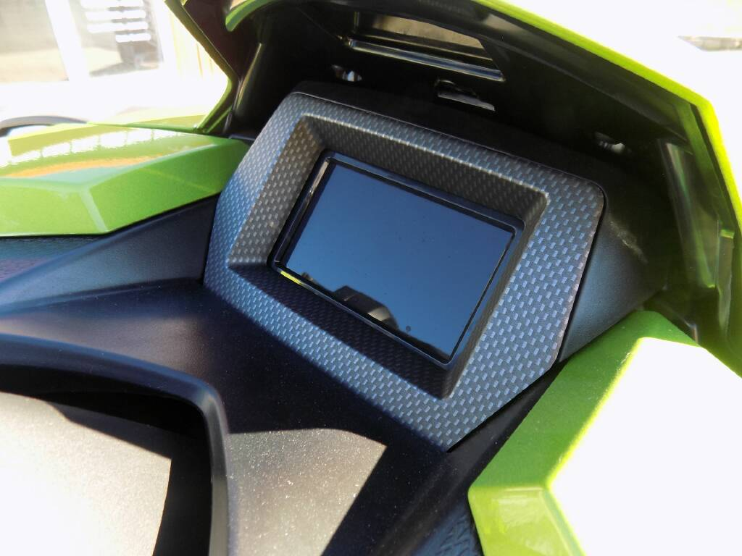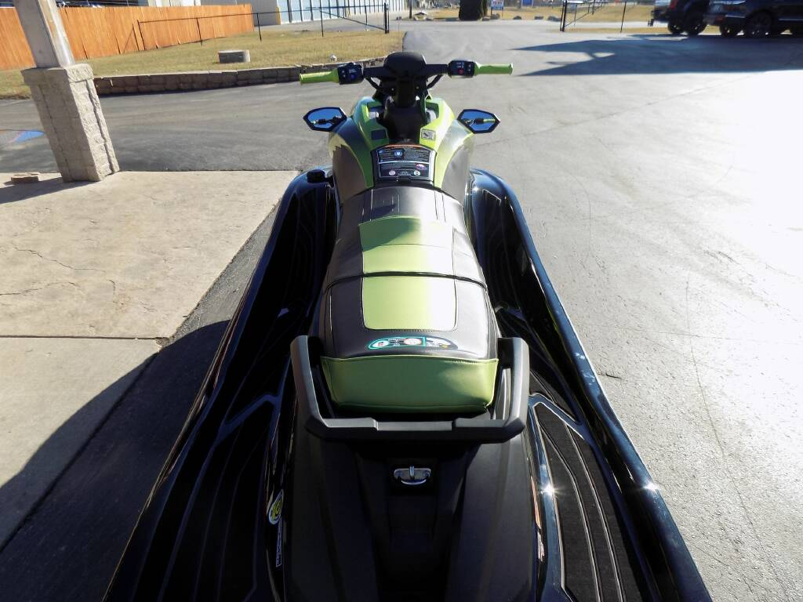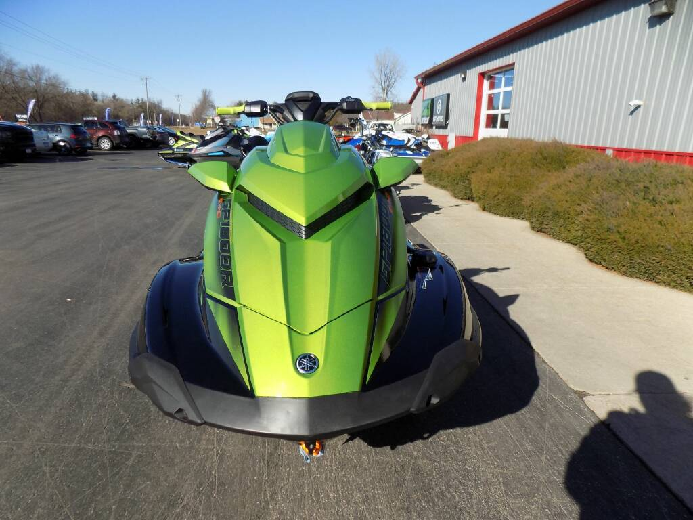

Condition New
Model Year 2023
Manufacturer Yamaha
Model GP1800R SVHO
Model Type Performance
VIN US-YAMA2775G323
Color Black / Acid Green

BODY
Storage Capacity - 28.4 gal.

DIMENSIONS
Length 131.9 in.
Height 47.2 in.
Width 48.8 in.
Weight Dry - 754 lb.

DRIVETRAIN
Transmission RiDE by Yamaha
Reverse in RiDE® with T.D.E.
Reverse Assist Mode
Pump 160 mm High-pressure

ELECTRICAL
Instrumentation Connext 4.3 in. screen with security and drive control
Fuel Gauge
Touchpad Control
Battery MF

ENGINE
Fuel Type Recommended - Premium Unleaded
Engine Supercharged 4-cylinder, 4-stroke, Super Vortex High Output Yamaha Marine
Displacement 1,812 cc
Fuel Capacity 18.5 gal.

OPERATIONAL
Seating 1-3 persons rider capacity
2-piece racing inspired

