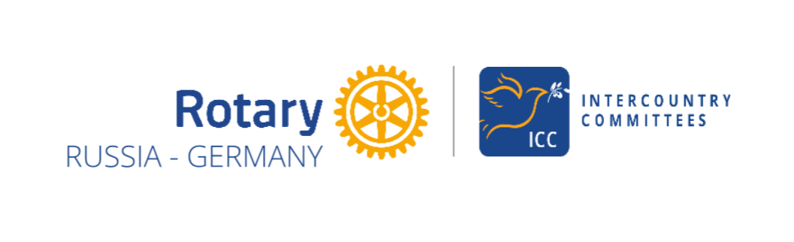
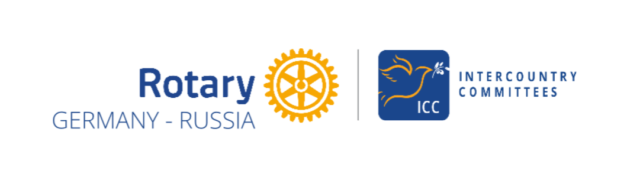
2025-26 Annual report of the ICC Russia-Germany

The ICC Board for 2025–26 comprised two section chairs (DGN Axel Richter, RC Hildesheim, D-1800, and PP Jens Strohschneider, RC Moscow Metropol, D-2223) and a secretary (PP Natalia Anisimova Krucker, Rotary e-Club of Russia, D-2223). From 1 July 2026, PP Svetlana Frolova, RC Moscow Metropol, D-2223, will take over as Chair of the Russian Section.
Contacts between the sections have been re-established and the website updated. The German section has 14 members from various districts in Germany, and the Russian section has 25 members from various clubs in District 2223 –
https://iccrussiagermany.org/members
The personal meeting in February 2025 at the RI Presidential Peace Conference in Istanbul laid the foundations for further successful work. Since then, monthly online meetings between the two sections have been held, featuring simultaneous interpretation. There is also regular contact with ICCs from various countries. There are plans in place to expand the German section to include Rotarians from Austria and Switzerland (D-A-CH).
The aim of our ICC’s work is to maintain existing links between Rotarians in Germany and Russia and to further develop these as a means of connecting with and strengthening Russian civil society. The focus of our work is on personal meetings, exchange programmes and joint cultural activities.

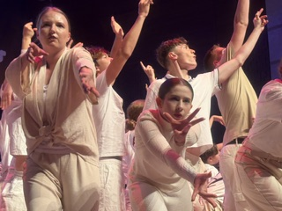
With the help of the ICC Germany–Turkey and the ICC Germany–Russia, and under the leadership of the association ’Music for Peace / Musik für den Frieden’ e.V., a Peace Camp involving young people from Germany and Russia was held in Turkey in October 2025. Both ICC sections provided financial support for the project, and ICC representatives were present on site. The highlight was two concerts in Izmir and Bursa, each attended by around 1,000 people.
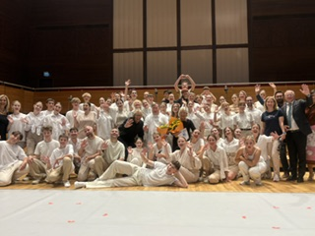

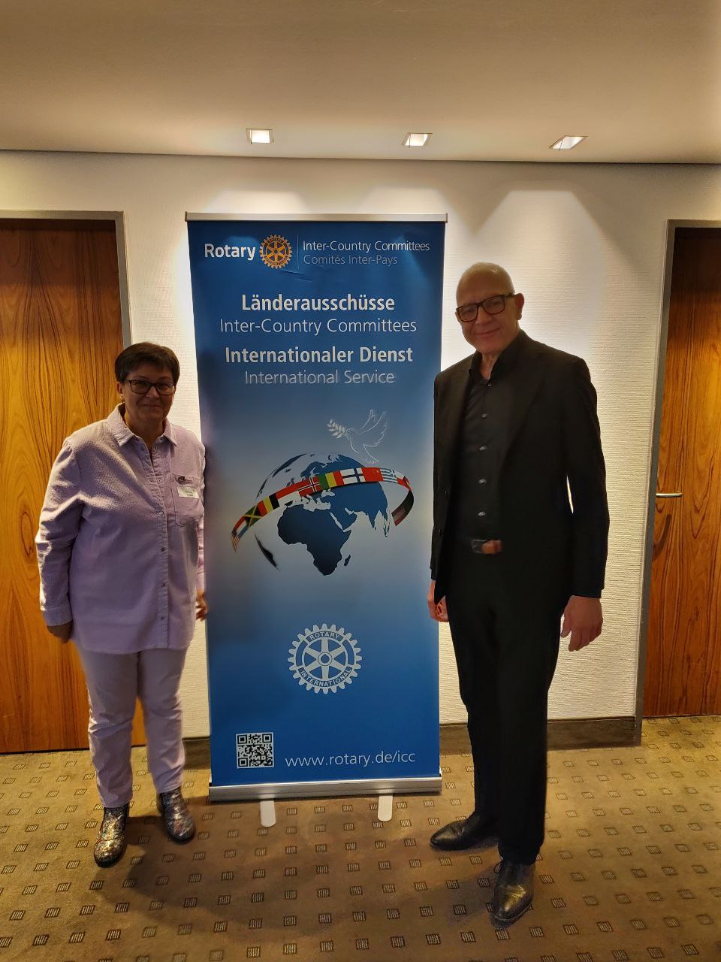
On 18 October 2025, Natalia Anisimova Krucker and Axel Richter attended the ICC meeting of the German national committees in Augsburg.

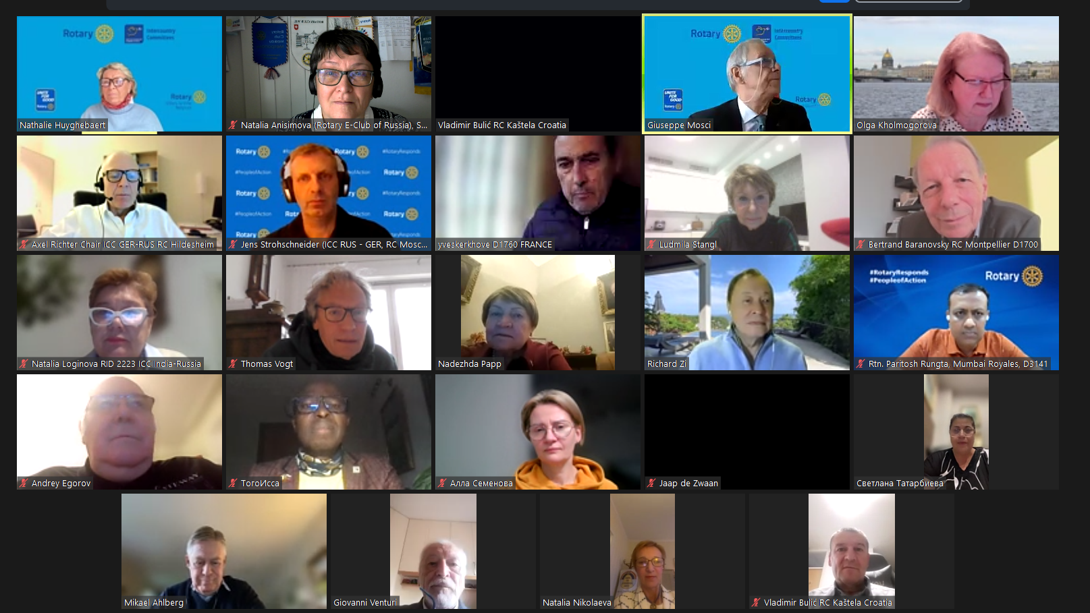
On 26 November 2025, an online meeting of all ICCs in District 2223, entitled “BUILDING PEACE AND PROMOTING HUMANITARIAN SERVICE”, took place. During this meeting, contact was established with ICC Executive Council Chair Nathalie Huyghebaert (Belgium) – see https://iccrussiagermany.org/news
In close consultation with the ICC Executive Council, the ‘Music for Peace’ project was nominated for the ICC Peace Award and was shortlisted.
In May 2026, two representatives from the German section of the ICC attended the District Conference in Moscow, Russia.
The conference programme included, amongst other things, a presentation on our ICC and a report on the ‘Music for Peace’ project – both of which met with great interest from the participants.

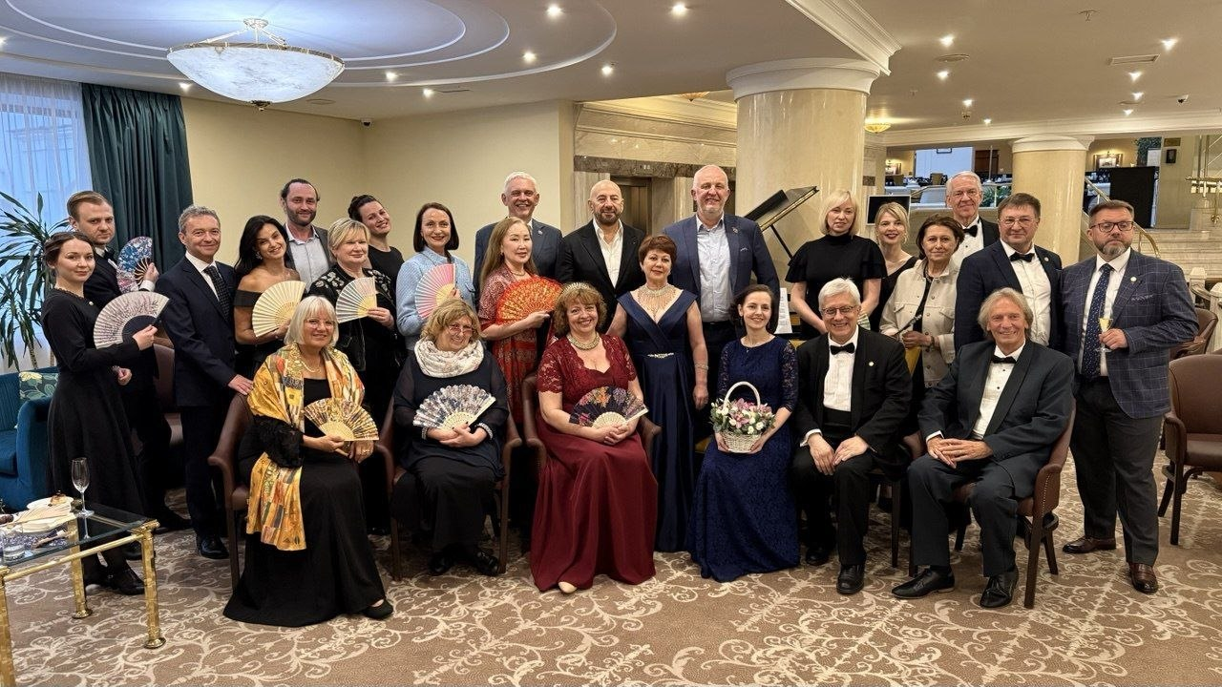
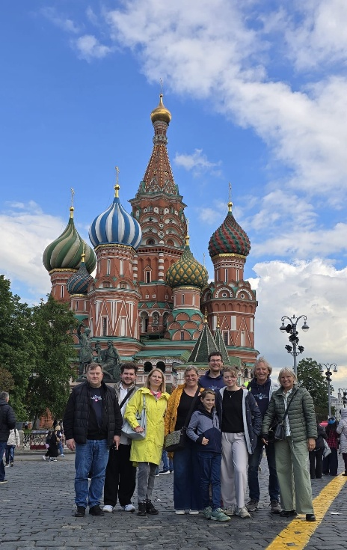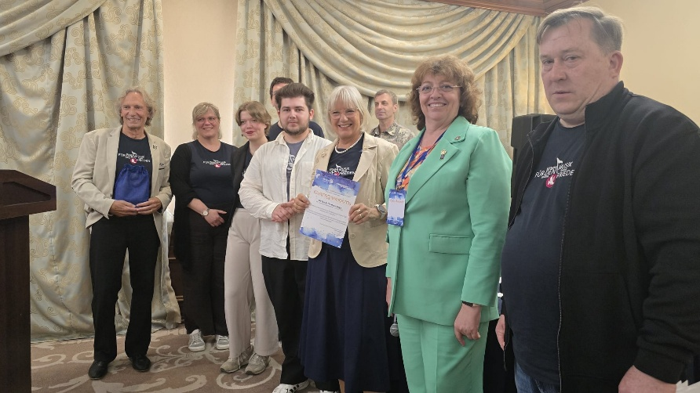

On 6 June 2026, representatives of the ICC attended the ‘Löwenherz’ Peace Prize award ceremony for ‘Music for Peace’ in Müllheim.
For the visit to Germany planned for autumn 2026, our ICC has already obtained visas for the Russian participants from the German Embassy in Moscow.

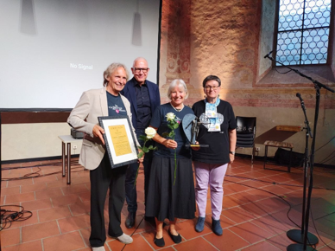

The following additional projects have been carried out or proposed for implementation:
- ‘We’re Going to Visit’ (joint online meetings for clubs in Germany and Russia) – RC Possenhofen Castle International, D-1841 + RC Vladivostok Territory of Peace, RC Kaliningrad, and REC of Russia, D-2223
- ‘Rotary Peace Poles’ – organised by RC Vladivostok Territory of Peace
- “Welcome to Kaliningrad” – Family Exchange for visitors from Germany, proposed by RC Kaliningrad
- Planned visit in 2027 by RC Togliatti to RC Wolfsburg, District 1800
- Matching Russian Rotarians, who are on business in Berlin, with local Rotary clubs
- Medical advice and referral services for Russian Rotarians
- Support for business links between Germany and Russia at Rotary level
- Preparatory work has begun on extending the Swiss ‘Mine-Ex’ project (aid for landmine victims) to Russia – an initiative by RC Bad Ragaz, D-2000; brief information about the project has been sent in text and video format to various organisations and NGOs in Russia.
- Initiated by RC Krasnodar, D-2223, preparations are underway for the International Rotarian Environmental Conference “The Value of Water” (to be held online in autumn 2026)
- Preparations are underway for a joint project, ‘Sound of Mountains’, with Rotarians from Austria

The ICC’s activities have been regularly reported on in Rotary media in Russia and Germany. The publications are prepared in collaboration between the two sections – see examples below.

https://rotary.de/online/detail/internationales-camp-setzt-zeichen-der-versaendigung
https://rotary.de/online/detail/d1930-musikfuerdenfrieden-preis

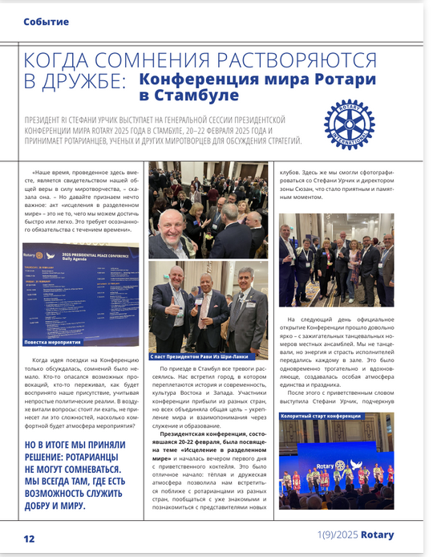
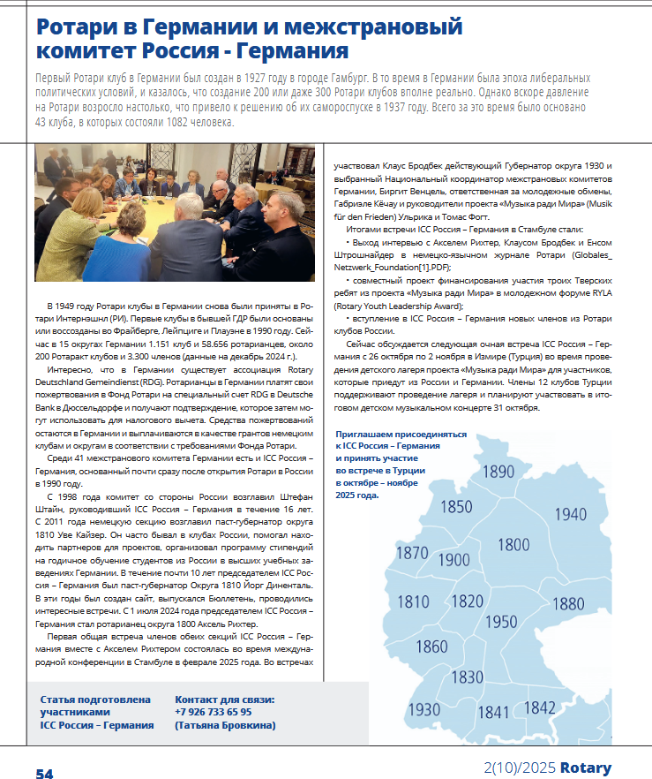
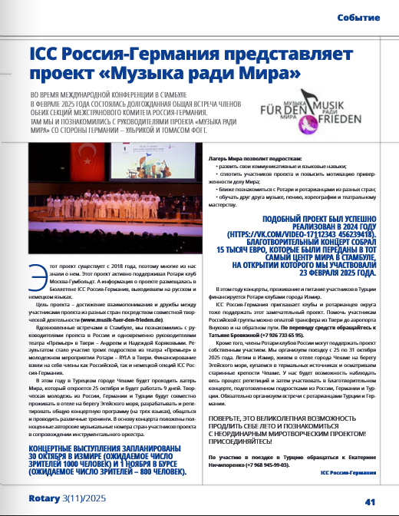
Axel Richter, RC Hildesheim, DGE 2027/28, District 1800
Chair of the German section of the ICC Germany-Russia
Jens Strohschneider, RC Moscow Metropol, District 2223
Chair of the Russian Section of the ICC Russia-Germany until 07/2026
Svetlana Frolova, RC Moscow Metropol, District 2223
Chair of the Russian section of the ICC Russia-Germany from 07/2026
Natalia Anisimova Krucker Wil/CH, E-Club of Russia, ICC-DEU-RUS Secretary

Hildesheim 24.06.2026

