Конспект открытого занятия элективного курса
Тема: «Christmas Traditions» («Рождественские традиции»)
- Предмет: английский язык
- Группа: 10 кл
- Количество учащихся: 7 человек
- Учитель: Глазунова Анастасия Николаевна
- Место урока в тематическом цикле: обобщающее занятие по теме «Праздники»
- Время: 1 урок (45 минут)
- Технология: мультимедийная презентация

Цели урока: повысить мотивацию к изучению английского языка, расширить словарный запас.

Задачи:
Методические: 1. совершенствование языковых навыков,
- символы Рождества,
- обычаи и традиции,
- языковые реалии, связанные с Рождеством,
2. развитие речевых навыков аудирования, чтения и говорения.
Дидактические:
- формирование навыков работы в группе.
Развивающие: расширить знания о традициях Великобритании и США

Программное обеспечение:
- Microsoft Power Point,
- Microsoft Word

Техническое обеспечение:
Компьютер, мультимедийный проектор и экран, принтер

Раздаточный материал:
Тренировочные упражнения

Формы взаимодействия:
- Групповая
- Фронтальная

Этапы урока:

- Орг. момент.
- Установка на урок (схема)
- Повторение лексики (Рождественские символы)
- Аудирование (Песня)
- Чтение(Nativity story)
- Отработка лексики в контексте (Рождественские традиции)
- Тест на проверку знания новых слов и выражений (Christmas Cloze)
- Подведение итогов. Выставление оценок.
- Домашнее задание
Ход урока

Этап | Время | Инструкции учителя | Деятельность учащихся
1 | 1 мин. | Приветствует группу, объявляет тему, цель и задачи | Приветствуют учителя
2 | 2 мин. | На доске схема, которую учитель просит заполнить в течение урока | Переносят схему в тетради, в течение урока заполняют схему
3 | 5 мин | Викторина «Рождественские символы» (презентация PowerPoint)  Прочитайте вопрос и выберите правильный вариант | Отвечают на вопросы викторины
4 | 5 мин | Живое исполнение песни «All I Want for Christmas»  Прослушайте песню и заполните пропуски | Слушают песню, заполняют пропуски
5 | 10 мин | Просит прочитать текст «The Nativity Story» и заполнить пропуски частями предложений | Читают текст, заполняют пропуски
6 | 10  мин | Просит выполнить задание на сопоставление «Christmas Matching» и рассказать о традициях Рождества в группе | Работают в группе: выполняют задание на сопоставление и рассказывают о рождественских традициях
7 | 10  мин | Просит заполнить текст словами из бокса (обобщение) | Выполняют задание индивидуально, затем проверяют в группе
8 | 1 | Подводит итоги. Выставляет оценки
9 | 1  мин | Предлагает выполнить домашнее задание (дополнить составленную на уроке таблицу и составить рассказ о праздновании Рождества в Великобритании и США) | Записывают домашнее задание

Материал к уроку
I
Santa Claus
Christmas characters

Christmas food
Christmas decorations
Christmas

Christmas traditions
Symbols of Christmas

II Read and complete the song with the words from the box.
Santa Clause tree stocking the North Pole mistletoe

Listen and check.
All I Want for Christmas
I don’t want a lot for Christmas
There is just one thing I need
I don’t care about the presents underneath the Christmas 1 __________
I just want you for my own
More than you could ever know
Make my wish come true
All I want for Christmas is you

I don’t want a lot for Christmas there is just one thing I need
I don’t care about the presents underneath the Christmas tree
I don’t need to hang my 2____________ way above the fireplace
3______________will make me happy with a toy on Christmas day
I just want you for my own
More than you could ever know
Make my wish come true
All I want for Christmas is you, you baby!

I won’t ask for much this Christmas
I won’t even wish oh I won’t even wish
I’m just gonna keep on waiting underneath the 4_________________
I won’t make a list and send it to 5____________for St Nick
Won’t even stay awake to hear the magic reindeer play

Cause I just want you here tonight,
Holdin’ on to me so tight
What more can I do
Oh baby all I want for Christmas is you, oh baby!
Oh our lives are shinin’ surrounding everywhere
Where the sounds of children’s laughter fills the air
And everyone is singin’ oh I hear those sleigh bells ringin’!
Santa won’t you bring me the one I really need
Won’t you bring back my baby to me?

Oh I don’t want a lot for Christmas
This is all I’m askin’ for!
I just want to see my baby standing right outside my door
I just want you for my own
More than you could ever know
Make my wish come true
All I want for Christmas is you, you, it’s you, you, oh baby!
All I want is you [x4]
You, you, you, you, you

III
Прочитайте текст и заполните пропуски 1-6 частями предложений, обозначенными буквами A-G. Одна из частей в списке A-G лишняя. Перенесите ответы в таблицу.
The Nativity Story (The Birth of Jesus)
More than two thousand years ago, in the town of Nazareth, there lived a young woman named Mary. She was engaged to be married to Joseph, a carpenter. One day an angel appeared before her and told she would have a special baby, God’s son,(1) ____________________.
Soon after the angel’s visit, Mary and Joseph were married. Mary was due to have her baby when they were told they had to go to Bethlehem to pay a special tax. Mary had to ride on a donkey for a few days over the hills of Galilee.
When Mary and Joseph arrived at Bethlehem it was crowded with people and all the inns were full. Mary was very tired and needed a place to stay. Eventually one kind innkeeper said he had a stable where he kept his animals (2) ______________________. A few hours later Mary gave birth to her son. She wrapped Jesus in strips of cloth and laid him in a manger full of hay.
At the same time, near Bethlehem, some shepherds saw a bright light in the sky. They were very afraid. It was an angel sent by God. The angel told them he had some good news. He said the son of God and the Saviour of the world had been born and they would find him in Bethlehem. The shepherds went to see the baby. When they arrived at the stable, they were filled with joy at (3) ________________. They knelt down and worshipped him.
Far away in the east, the Three Wise Men, (4) ________________, saw a new star shining in the sky. They knew whenever the bright star appeared it meant that a great ruler had been born. The wise men decided to find this new ruler. They went to Jerusalem to see King Herod, as they thought the baby would be in the palace. They asked to see the child that would be the king of the Jews. The king was troubled. He thought this new king may take away his throne. He told the Wise Men to return when they had found the baby so that he could worship the child himself.
The Wise Men set off to find the baby. They were guided by the star to the stable of Bethlehem. Here they knelt and worshipped Jesus. They gave him gifts of gold, frankincense and myrrh. That night, the men had the same dream (5) ______________ and told them not to go back to his palace. So the Wise Men went back to their country.
Soon after that Joseph had a dream where the angel told him to take Mary and Jesus to Egypt. They left Bethlehem right away. When the Wise Men didn’t return, Herod ordered (6) _________________. They didn’t find Jesus as he was safe.
A. seeing Jesus lying in the manger
B. and she must call him Jesus
C. that baby boys in Bethlehem be killed
D. where an angel warned them that King Herod wanted to kill Jesus
E. called the Magi
F. and offered to stay there with his sheep
IV Christmas matching
Match the verbs with the phrases and find the pictures
What do we do at Christmas?

Make
Buy
Sing
Eat
Pull
Put up
Hang
Decorate
Listen to
Send
Kiss
Go to
Read
Write

houses with lights
A Christmas tree
Christmas pudding
The Queen’s speech
The Nativity story
Christmas cards
Christmas stockings
Church
A letter to Santa
Christmas carols
Crackers
Under the mistletoe
Presents
Christmas decorations

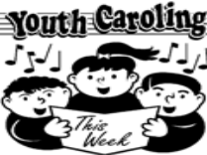1 2 3 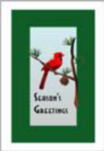4 5
6 7  8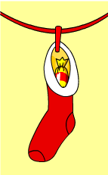 9
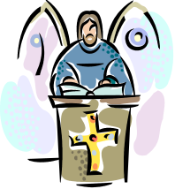10 11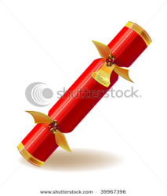12 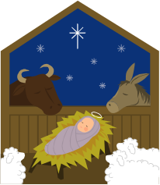13 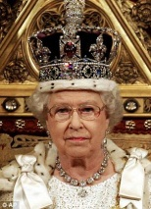 14

V

Christmas Cloze
Fill in the blanks with words from the box:
checks  naughty  North Pole  lap  cards  sleigh  coal | nice  beard  decorate  baked  presents  holiday  toys | sing  Boxing  elves  turkey  under  reindeer  merry | fills  Eve  workshop  lights  chimney  family  spirit

Christmas:
Christmas is a 1____ when people get together with 2____. People give 3______ to each other or send 4_____ wishing each other a 5_____ Christmas. At Christmas, people 6____ carols to get into the Christmas 7_____. As well, people 8_______ Christmas trees and put up 9______ around the house. A common Christmas dinner is 10____. There are also lots of 11______ goodies for the kids. Christmas begins on the day before Christmas, or Christmas12 _____ and continues until 13_____ Day, when many people go shopping for sales.

Santa Claus:
Santa Claus is an old man with a white _________________ that lives at the __________________. Children sit on Santa’s _________________ and tell him what they want for Christmas. Santa _________________ his list to see if the children have been _________________ or _________________. If the children are bad Santa brings them __________________. If the children are good Santa brings them ____________________. The toys are made in Santa’s
___________________ by _________________. Santa travels around the world in his _________________, which is pulled by flying ___________________. When he stops at a house, he goes down the __________________ and puts presents _________________ the tree and then he _________________ the stockings. | 